**STM4PSD ASSIGNMENT 2**

In submitting my work, you are consenting that it may be copied and transmitted by the University for the detection of plagiarism. Submission is your guarantee that the below statement of originality is correct.

*“This is my own work. I have not copied any of it from anyone else.”*

NAME: **Maninderpreet Singh Puri**

STUDENT NUMBER: **20494381**

Given X ~ BIN (960, 0.0015)

E (X) = *np=* 960 * 0.0015*=* 1.44 *Using Result 5.3.1*

Var (X) = *np (1-p) =* 960 * 0.0015 * (1- 0.0015) = 1.438  *Using Result 5.3.1*

(b)

Given P (X=0), n=960

Using Binomial distribution X ~ BIN (*n,p*) and $pX\left(x\right)$ = $\left({n \atop x}\right)p^{x}{\left(1-p\right)}^{n-x}$

* P (X=0) = $\left({960 \atop 0}\right){0.0015}^{0}{\left(1-0.0015\right)}^{960-0}$
* $\left({960 \atop 0}\right)$ can be written as $\frac{960}{0!(960-0)!}$ = 1 *Using 5.2.1*
* P (X=0) = $1*1 {(0.9985)}^{960}$*=* 0.237

So, the probability that there are no containers with rotten food in the sample is 0.237

(c)

* P (X=1) = $\left({960 \atop 1}\right){0.0015}^{1}{\left(1-0.0015\right)}^{960-1}$
* 960 * 0.0015 ${(0.9986)}^{959}$* = 0.341

So, the probability that there is exactly one container with rotten food in the sample is 0.341

(d)

Probability of at least 3 containers to have rotten food P (At least 3) can be described as

P (At least 3) = 1- (P (X=0) + P (X=1))

So using the results from (b) and (c)

P (At least 3) = 1- 0.237 + 0.341) = 1- 0.578 = 0.4217

(e)

Given E (X) = 1.44

For Poisson Distribution E (X) can be described as λ. So λ = 1.44.

Using Poisson distribution X ~ POIS (λ) and $pX(x)$ = $\frac{λ^{x}{ e}^{-λ}}{x!}$

* P (X=0) = $\frac{{1.44}^{0}{ e}^{-1.44}}{0!}$ = 0.237
* P (X=1) = $\frac{{1.44}^{1}{ e}^{-1.44}}{1!}$ = 0.341
* P (At least 3) = 1- (P (X=0) + P (X=1)) = 1 – (0.237 + 0.341) = 0.422

Both approximations of Poisson and Binomial distributions are close.

(a)

According to the information given in the question, λ = 5 and $μ$ = 7.

So the Traffic intensity for the delivery bay is ρ = $\frac{λ}{μ}$*Using reading 6.4.1*

ρ = $\frac{5}{7}$ = 0.714

(b)

*Using reading 6.4.2*

Average amount of time that a truck will spend being unloaded in the delivery bay can be given by

Expected (mean) service time = $\frac{1}{μ}$ = $\frac{1}{7}$ = 0.14 * 60 (into minutes) = 8.57 minutes

(c)

*Using Result 6.4.2*

Average waiting time of a truck before unloading the contents of their truck in the delivery bay can be given by

$W_{Q}$ = $\frac{λ}{μ(μ-λ)}$ = where λ = 5 and $μ$ = 7.

So by substituting value in $W_{Q}$ we get,

* $\frac{5}{7(7-5)}$ = $\frac{5}{14}$ = 0.357 * 60 (into minutes) = 21.42 minutes

(d)

*Using Result 6.4.1*

Long term average number of trucks in the system at any one time can be given by

L = $\frac{λ}{μ-λ}$ = $\frac{5}{7-5}$ = $\frac{5}{2}$ = 2.5

(e)

Average time a driver will spend in the system (this includes time waiting in the queue and time unloading in the delivery bay) can be given by,

$W$ = $\frac{L}{λ}$ = $\frac{2,5}{5}$ = 0.5 * 60 (into minutes) = 30 minutes

(f)

i.

R code:

windows(height = 6, width= 8)

WQ <- function(lambda , mu){

out <- lambda/(mu*(mu - lambda))

}

curve(WQ(5 , x), from = 5.1, to = 15 ,ylab = "Average amount of waiting time of a truck (in hours)", xlab ="Arrival rate of trucks (per hour)", lwd= 2, col ="red")

Output:

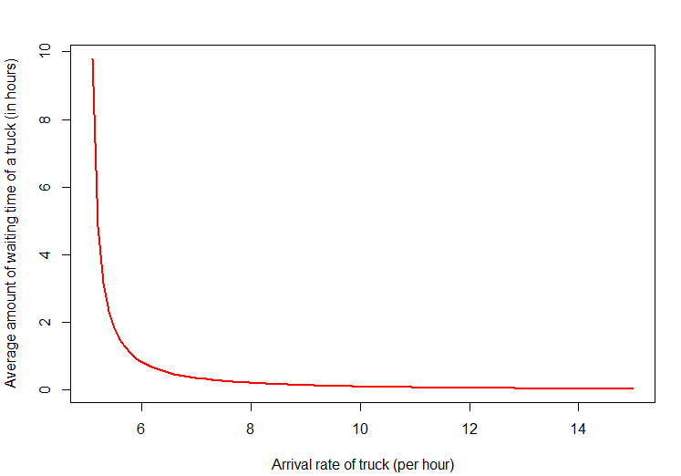

So according to the graph the average time spent in the queue decreases as lambda increases.

ii.

So from the given information in the question we can say that,

$W_{Q}$ = 15, and taking $λ$ = 5 we can solve for $μ$.

$W_{Q}$ = $\frac{λ}{μ(μ-λ)}$

* 15 = $\frac{5}{μ(μ-5)}$
* 3 $μ^{2}$– 15 $μ$– 1 = 0 *(Quadratic equation)*
* Now solving Quadratic equation by Quadratic formula we get,
* $μ ≅$- 0.065 and 5.065  
  So ignoring the negative value of $μ$ we can say that the minimum rate at which the new staff need to process the contents of a delivery truck, so that they meet these performance standards is 5.

(a)

We have $μ$ P1 = 3 $λ$ P0

So that P1 = 3 $\frac{λ}{μ}$ P0

* P1= 3 ρ P0 *As given ρ = λ/µ*

(b)

The rate out of state 1 is ($μ+3λ$) P1 and the rate into state 1 is $3λ P0+μ P2$

Equating both we get.

* ($μ+3λ$) P1 = $3λ P0+μ P2$
* P2 $μ$ = ($μ+3λ$) P1 - $3λ P0$
* P2 = (1 + 3 ρ) P1 - 3 ρ P0
* P2= (1 + 3 ρ) (3 ρ P0) - 3 ρ P0 *Using P1= 3 ρ P0*
* P2 = 9 $ρ^{2}$ P0

(c)

The rate out of state 2 is ($μ+2λ$) P2 and the rate into state 2 is $3λ P1+μ P3$

Equating both we get.

* ($μ+2λ$) P2 = $3λ P1+μ P3$
* P3 $μ$ = ($μ+2λ$) P2 - $3λ P1$
* P3 = (1 + 2 ρ) P2 - 3 ρ P1
* P3= (1 + 3 ρ) (9 $ρ^{2}$ P0) - 3 ρ (3 ρ P0) *Using P1= 3 ρ P0 and P2 = 9 $ρ^{2}$ P0*
* P3 = 18 $ρ^{3}$ P0

The rate out of state 3 is ($μ+λ$) P3 and the rate into state 3 is $2λ P2+μ P4$

Equating both we get.

* ($μ+λ$) P3 = $2λ P2+μ P4$
* P4 $μ$ = ($μ+λ$) P3 - $2λ P2$
* P4 = (1 + ρ) P3 - 2 ρ P2
* P4= (1 + ρ) (18 $ρ^{3}$ P0) - 2 ρ (9 $ρ^{2}$ P0) *Using P3= 18 $ρ^{3}$ P0 and P2 = 9 $ρ^{2}$ P0*
* P4 = 18 $ρ^{4}$ P0

The rate out of state 4 is ($μ+λ$) P4 and the rate into state 4 is $λ P3+μ P5$

Equating both we get.

* ($μ+λ$) P4 = $λ P3+μ P5$
* P5 $μ$ = ($μ+λ$) P4 - $λ P3$
* P5 = (1 + ρ) P4 - ρ P3
* P5= (1 + ρ) (18 $ρ^{4}$ P0) - ρ (18 $ρ^{3}$ P0) *Using P3= 18 $ρ^{3}$ P0 and P4 = 18 $ρ^{4}$ P0*
* P5 = 18 $ρ^{5}$ P0

(d)

According to the given information in the question, sum of all states is 1.

So,

P0 +P1 + P2 + P3 + P4 + P5 = 1

P0 + 3 ρ P0 + 9 $ρ^{2}$ P0 + 18 $ρ^{3}$ P0 + 18 $ρ^{4}$ P0 + 18 $ρ^{5}$ P0 = 1

(1 + 3 ρ + 9 $ρ^{2}$ + 18 $ρ^{3}$ + 18 $ρ^{4}$ + 18 $ρ^{5}$)P0 = 1

P0 = ${(1 + 3 ρ + 9 ρ^{2} + 18 ρ^{3} + 18 ρ^{4}+ 18 ρ^{5})}^{-1}$

(e)

Given $λ$ = 1, $μ$ = 3

$ρ$ = $\frac{λ}{μ}$ = $\frac{1}{3}$

i.

Probability that no server broken is

P0 = ${(1 + 3 ( \frac{1}{3}) + 9{( (\frac{1}{3})}^{2}) + 18{( (\frac{1}{3})}^{3}) + 18{( (\frac{1}{3})}^{4}) + 18{( (\frac{1}{3})}^{5})}^{-1}$*Using (d)*

* P0 = ${(1 +1+1+ \frac{2}{3}+ \frac{2}{9}+ \frac{2}{27})}^{-1}$
* ${(\frac{107}{27})}^{-1}$ = $\frac{27}{107}$ = 0.252

ii.

Probability that all servers are broken is

* P5 = 18 $ρ^{5}$ P0
* P5 = 18 $*{ (\frac{1}{3})}^{5}*$ $\frac{27}{107}$ = 0.019

iii.

Probability that exactly one server broken is

P1= 3 ρ P0

= 3 $\frac{1}{3}$* * 0.252 = 0.252

(e)

Probability of at least two servers working at any given time can be given as,

P0 + P1 + P2 +P3 = 1- (P4 + P5)

* P4 = 18 $ρ^{4}$ P0 = 18 $*{ (\frac{1}{3})}^{4}*$ $\frac{27}{107}$ = 0.056
* P0 + P1 +P2 + P3 = 1- (0.056 + 0.019) = 0.925 *Using (e) ii.*